Chapter 11 - Data is the New Oil

Contents

* HOC

* Controlled Component

* Uncontrolled Component

* Lifting the state up

* Build your own Accordion

* React dev tools

* Context API

What is Higher Order Component (HOC)?

A higher-order component is a regular JavaScript function that takes an existing component as input, modifies it, and returns an enhanced component. We are not changing the core functionality of the component; instead, we are enhancing it by adding additional functionality on top. This is why HOCs are also referred to as pure functions.

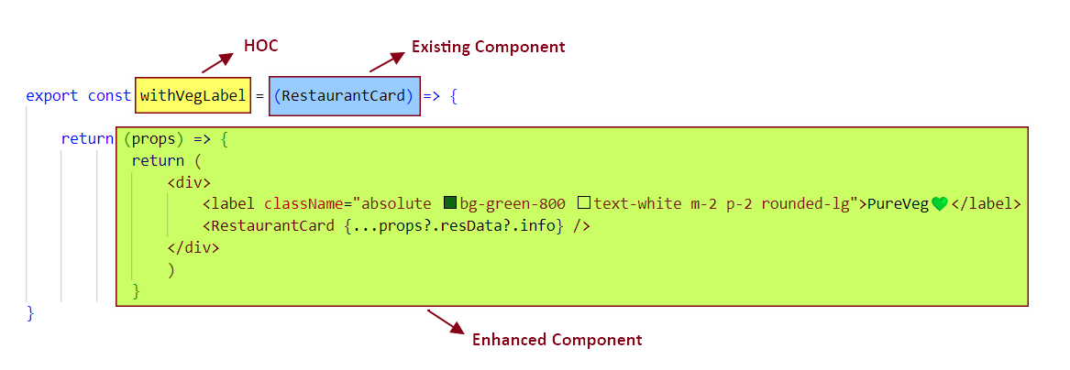

In this example, we have created a higher-order component, withVegLabel, which takes the RestaurantCard component as input and returns an Enhanced card component as output.

The Enhanced card component includes a "PureVeg" label and receives data as props from the caller, passing these props to the existing RestaurantCard component. HOC does not alter the functionality of the RestaurantCard component. This is why withVegLabel is also referred to as a pure component.

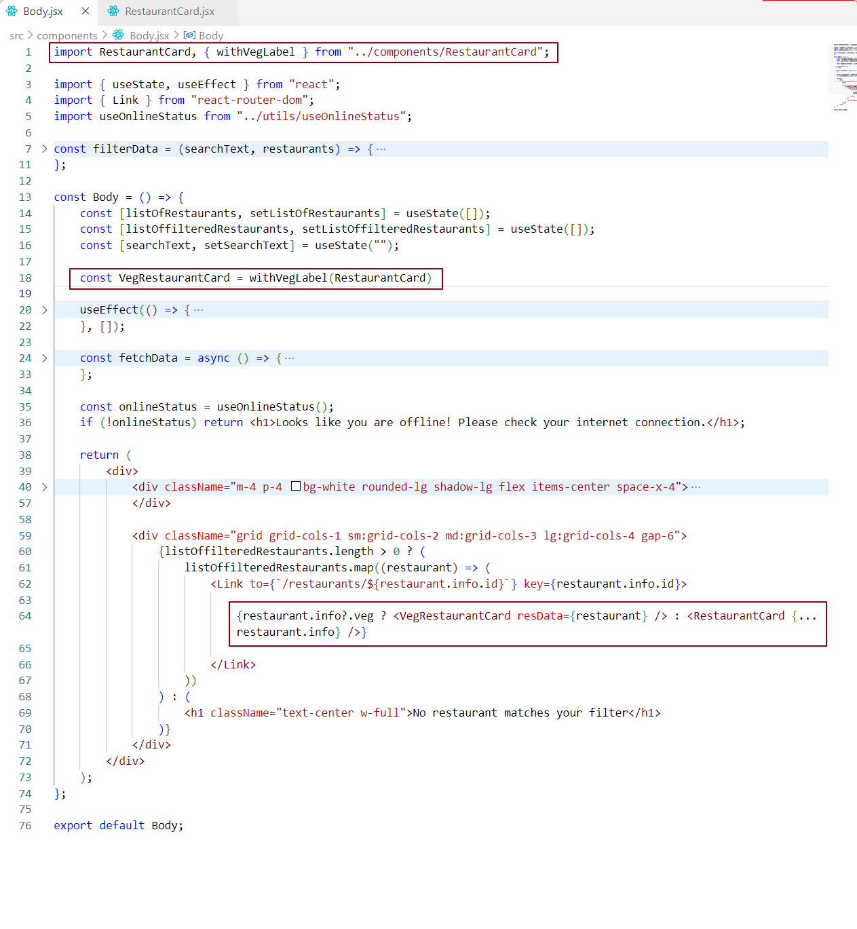

In this code snippet, at line 18, we invoke the HOC withVegLabel, which takes RestaurantCard as an argument and returns an enhanced component. This enhanced component is a function that accepts a single parameter, props (refer to Figure 1 for the structure of the enhanced component).

The enhanced component is then assigned to VegRestaurantCard. At line 64, we render VegRestaurantCard conditionally: if the restaurant is vegetarian, we display the enhanced card component; otherwise, we render the standard RestaurantCard component.

When we say "display the enhanced veg component" it means rendering the VegRestaurantCard component. While rendering this enhanced component, we pass the required props as resData.

Notes: We are passing props to the enhanced component, which is the same as passing props to the function returned by the HOC.

The UI now appears as follows:

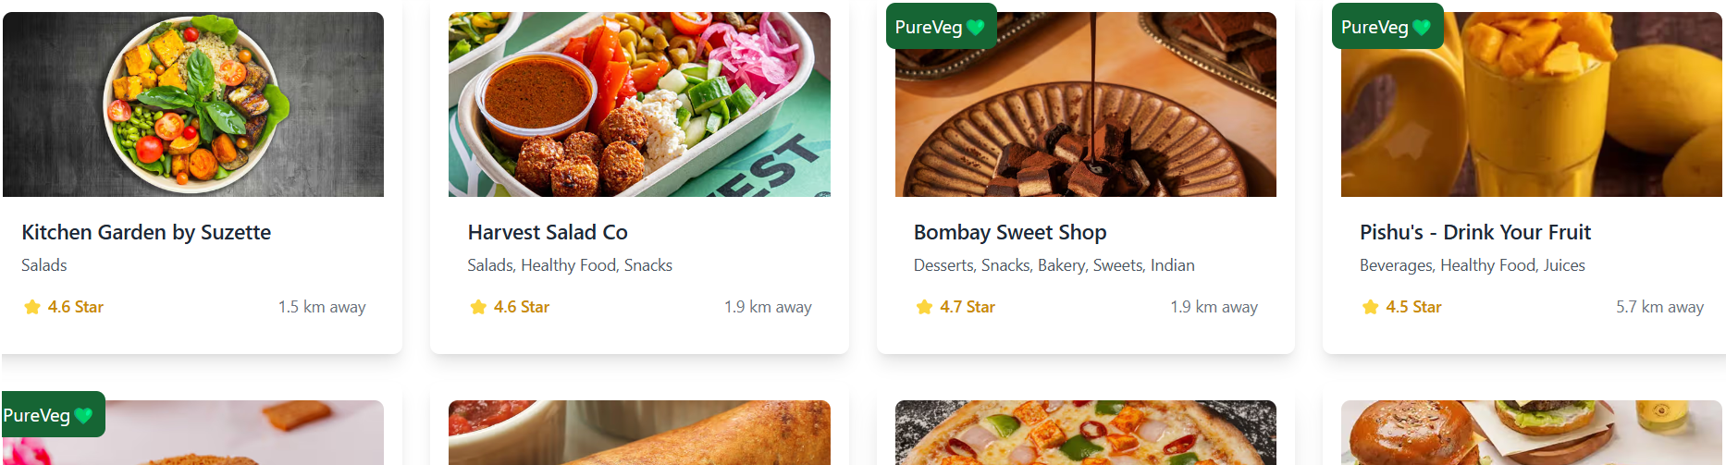

PureVeg cards: Enhanced component  
Other cards: Existing component

Every React application has two layers: the UI layer and the data layer. The UI layer is powered by the data layer.

* In the data layer, we manage application data using props, states, local variables, context, and hooks.
* In the UI layer, we manage JSX to control the look and feel of the application.

Accordion Template

Let's start by adding the accordion layout to our project. Before implementing its interactive functionality, we'll first focus on designing the accordion structure and appearance.

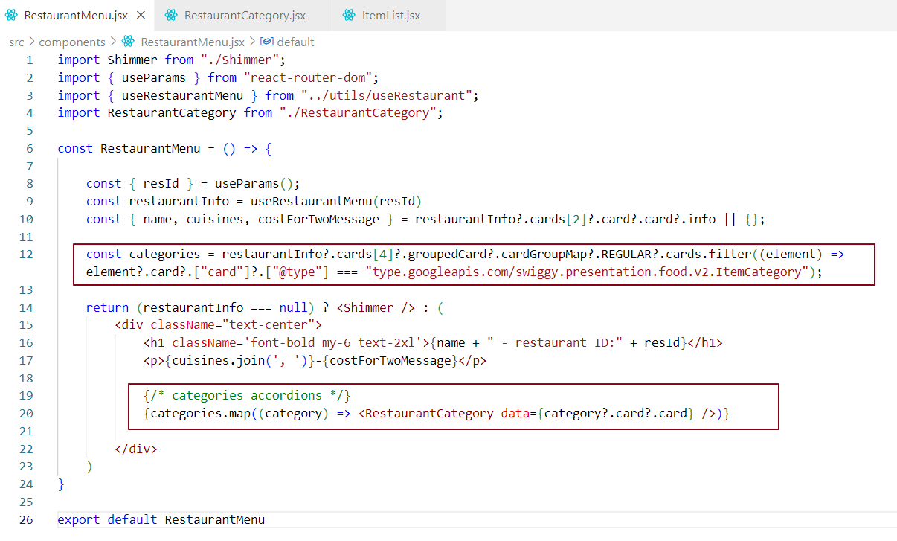

In line 12, we are fetching the list of categories, which will be used to display the accordion structure. The category header will be the accordion header, and the category content will be the accordion content. To achieve this, we need to call the RestaurantCategory component for each category. This ensures that each category has its own header and content, and we are rendering the RestaurantCategory component at line 20.

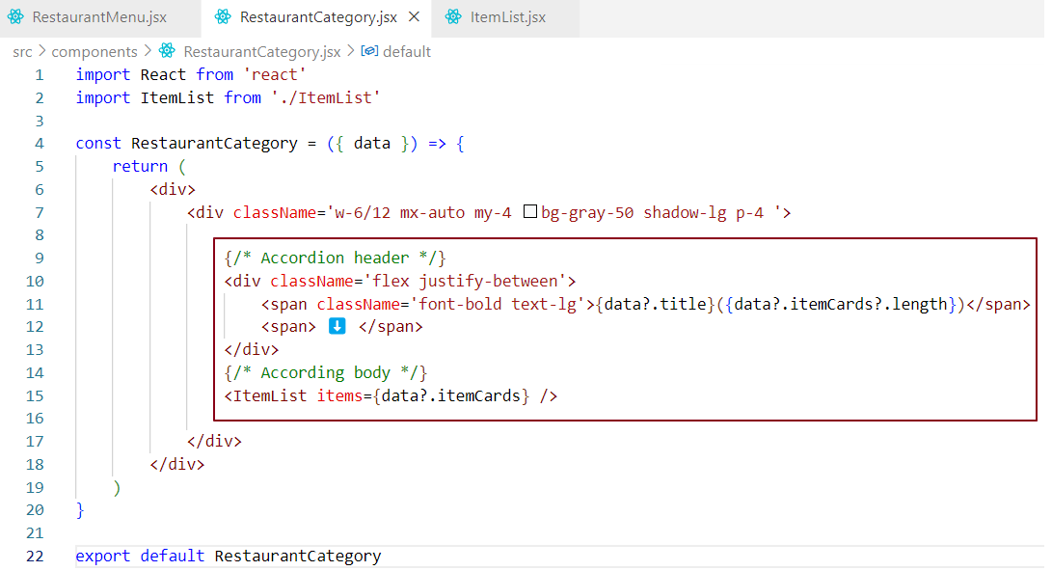

In the RestaurantCategory component, we are forming the Accordion structure. The category title, along with the number of items in that category, is displayed as the accordion header. The ItemList component, which contains the list of items for each category, is used as the accordion body for each category.

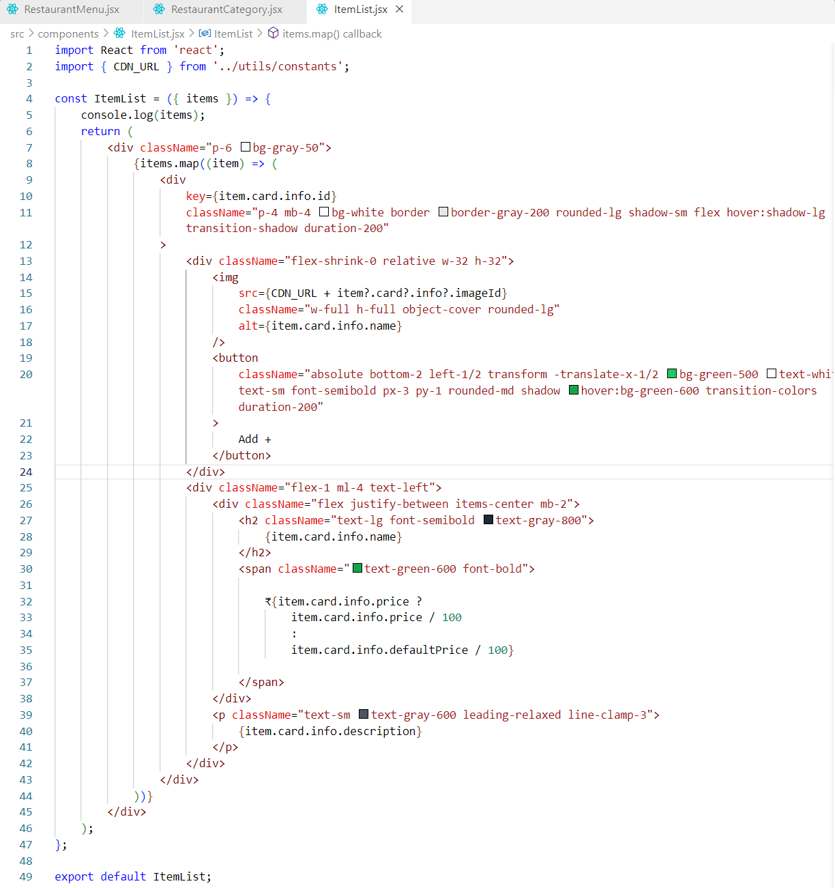

The ItemList component renders a list of items with each item having an image, name, price, and description. It maps over the items array and displays each item in a styled card with a hover effect. The image is displayed in a square container with a button ("Add +") positioned at the bottom centre.

The item name and price are displayed in a row, with the price formatted as currency (dividing by 100). If the price is unavailable, the component falls back to the default price.

The description is shown below the name and price, limited to three lines with ellipsis if it's too long.

Each item card is styled with rounded corners, a subtle shadow, and a clean layout using Tailwind CSS utilities, ensuring responsiveness and interactivity with hover effects.

We have already implemented the display of multiple categories in the accordion structure. However, I’ve added a screenshot for just one category header and its content for documentation purposes. This is to illustrate the layout as it currently appears, but rest assured, the final implementation will cover all categories in the app.

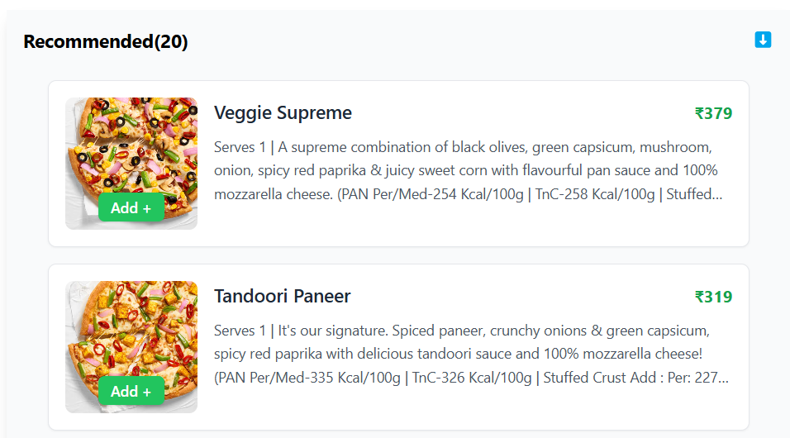

Now that we have created the accordion structure, let's proceed to add functionality to it.

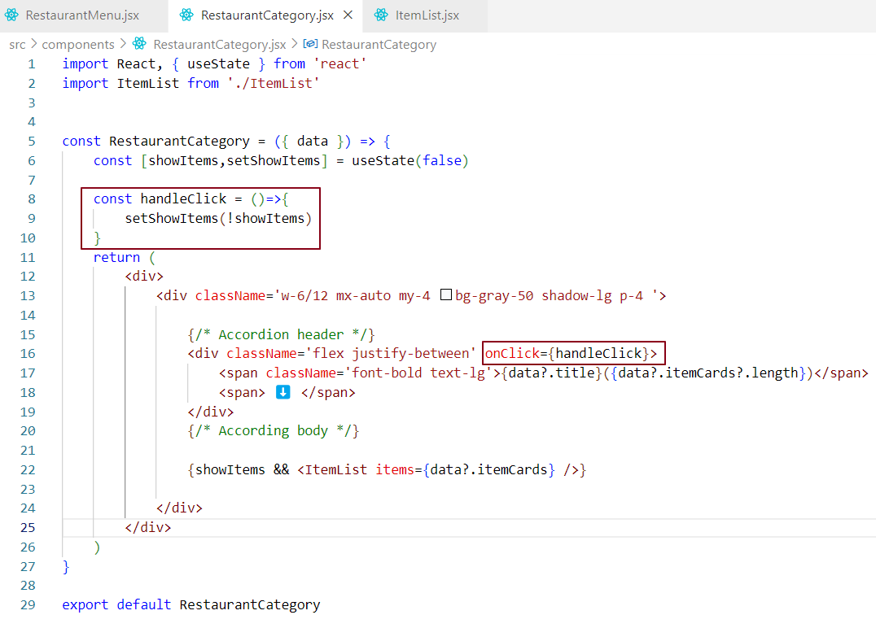

We have added toggle accordion functionality. When we load the RestaurantMenu component, it renders multiple RestaurantCategory components, each representing a category accordion. Initially, all category accordions are collapsed because the showItems state for each category is set to false, which means the content (ItemList) of the accordion is not displayed when showItems is false.

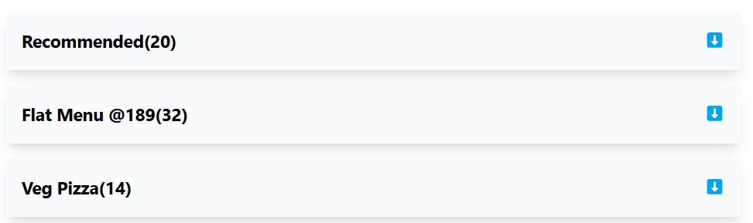

When we click on a specific category/accordion header the showItems state for that category is toggled to true, causing the accordion content to be shown.

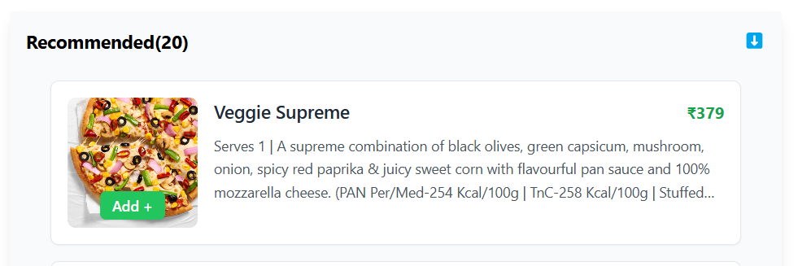

Clicking again on the header will hide the content by toggling showItems back to false.



Currently, each RestaurantCategory (child component) has its own showItems state to control the expansion and collapse of the accordion. However, to allow one accordion to expand while collapsing another, we need to lift the state up to the parent component, RestaurantMenu.

By moving the showItems state to the RestaurantMenu component, we can manage the expanded or collapsed state for all child components. This allows us to control the accordion states from the parent and makes it easier to sync actions like expanding or collapsing all categories at once. This is called "lifting state up" in React, where the parent manages the state and passes it down to the children.

Lifting the state up -

Lifting state up is a concept in React where you move the state from a child component to its parent component. This approach is used when multiple child components need to share or interact with the same state.

Here’s how it works:

1. **Initial State in the Child**: In a typical React setup, each component may have its own internal state. But when multiple components need to access or modify the same data, it’s not efficient to store the state in each of them.
2. **Move the State to the Parent**: Instead of keeping the state in the child components, you move it to the parent component. The parent will hold the state and be responsible for managing it.
3. **Pass State and Functions to Children**: The parent component then passes the state as props to the child components. It also passes down functions (handlers) to modify the state. This ensures that child components can update the state in the parent when needed.
4. **Synchronization**: With the state lifted to the parent, any child that needs to read or modify the state will now do so through the parent. The parent manages and synchronizes the state for all children.

**Why Use It?**

* **Sharing State Between Siblings**: If two or more child components need to share or synchronize state, you lift the state up to their common parent.
* **Centralized State Management**: It ensures the state is controlled by a single source of truth, avoiding issues with state duplication or inconsistency.
* **Better Control**: The parent component can control the state and pass down necessary data or functionality to its children.

### Example:

In our case of accordion example, if we want to ensure that only one category accordion is expanded at a time, we would lift the showItems state from each RestaurantCategory child to the RestaurantMenu parent. The parent would control which accordion is expanded, and it would pass down the necessary props and functions to each child.

In short, "lifting state up" makes the parent component the "single source of truth" for shared state, helping to maintain consistency and allowing for better control over the child components.

Let's implement the "lifting state up" approach for our accordion functionality. Before proceeding, let's first visualize the states and components using React DevTools to better understand the component structure and state management.

### **React Developer Tools (React DevTools)**

React Developer Tools is a browser extension designed for inspecting and debugging React applications. It provides insights into the component structure and performance.

### **Why Use React DevTools?**

1. **Debugging** - Easily inspect the React component hierarchy.
2. **Performance Optimization** - Use the Profiler to find re-render bottlenecks.
3. **Real-Time Updates** - Modify state and props directly in the tools and observe changes instantly.

### **Key Features**

### 1. ****Component Tree Inspection****

* View the structure of your React components.
* Check **props, state,** and **context** of any component.
* Highlights parent-child relationships between components.

**2**. **Profiler**

* Record performance metrics of your app.
* Visualize component re-renders and time taken for updates.
* Helps identify unnecessary renders or expensive operations

**3. Edit Props and State**

* Modify props and state directly in the DevTools.
* Test changes without modifying the actual code

**4. Hooks Debugging**

* Inspect values of **React hooks** (like useState, useEffect, etc.).
* View and debug custom hooks

**5. Search**

* Search for components in the component tree by name.

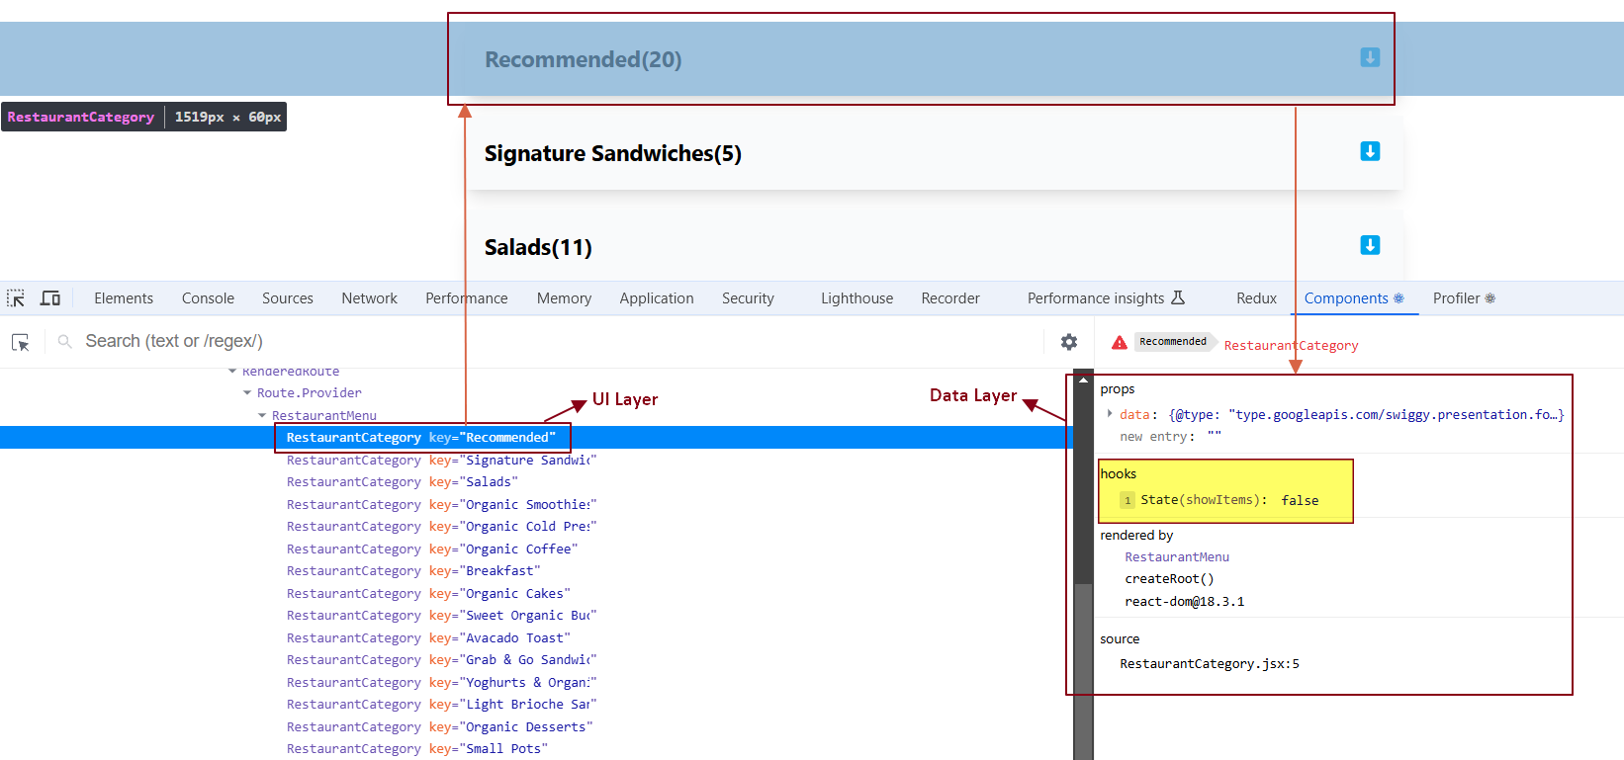

Each RestaurantCategory component will have its own showItems state. As shown in the figure, the first RestaurantCategory accordion is collapsed, meaning the showItems state for this component is set to false. If we expand this accordion, the showItems state for this specific component will change from false to true.

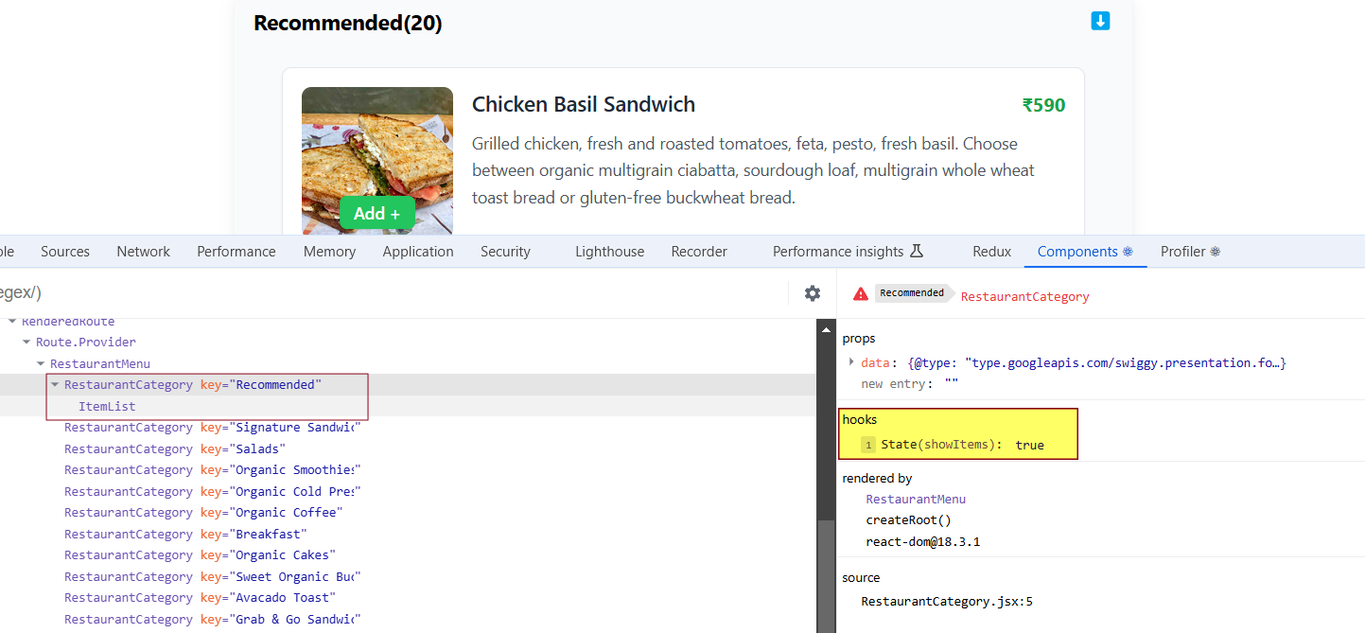

Now, if we look at the second RestaurantCategory accordion component, its showItems state is still set to false because it has not been expanded yet.

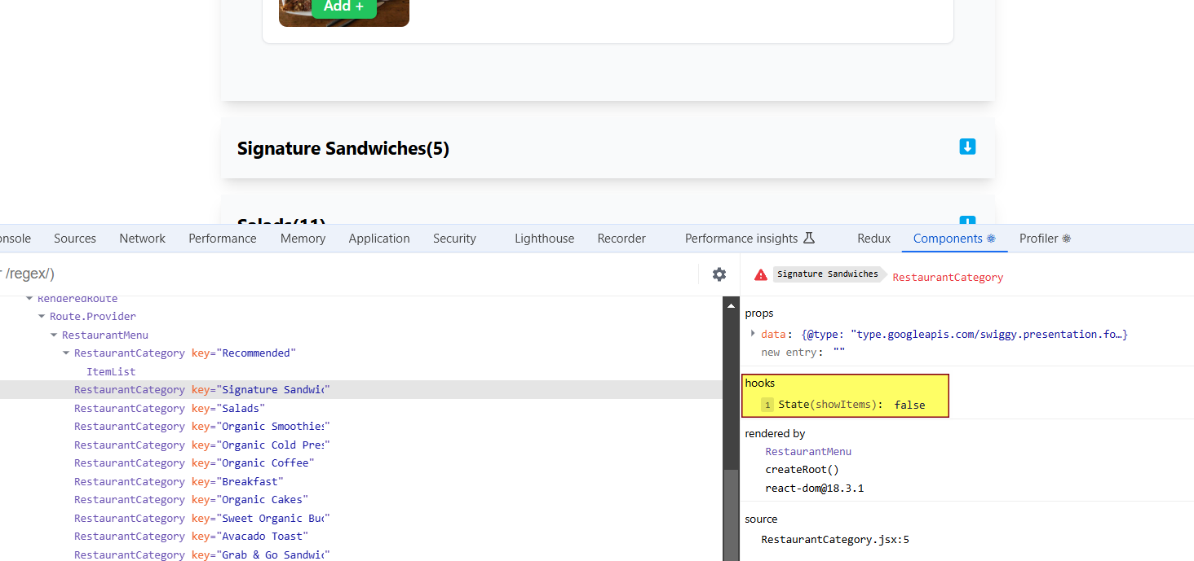

In the component hierarchy below, the ItemList component receives props from the RestaurantCategory component, as shown in the data layer on the right-hand side.

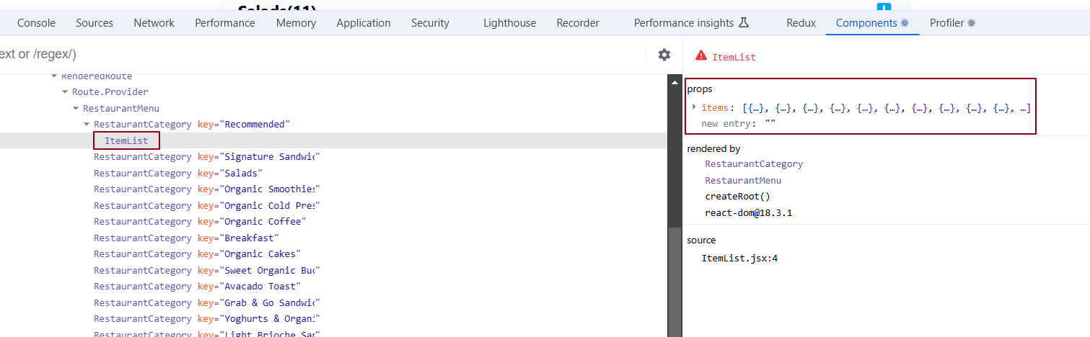

What is Profiler in React dev tools?

When we build large scale application with so many components in it, it becomes very tough to debug. Profiling records the whole user journey. whatever operation user has performed on the UI, Profiler shows us how the page was rendered. The react dev tools Profiler tracks user actions on UI and displays the entire user journey through a Flame graph.

Profiler provides a **ON** **OFF** switch to turn **ON** and **OFF** the recording. To see the Flame graph, we have to start the recording, play with the UI and then stop the recording manually.

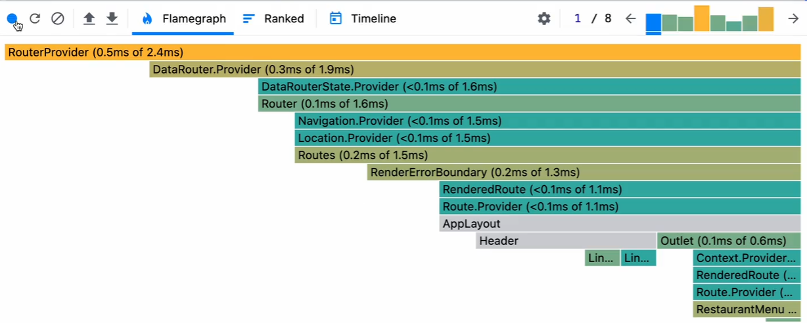

Flame Graph represents how long does it take for a component to load on UI. Flame Graph shows the time taken by Layout effect and passive effects to render on UI.

When implementing an accordion, if one RestaurantCategory accordion is expanded, it’s important for all other RestaurantCategory components to be aware of this state change. To achieve this, we’ll use the "lifting the state up" concept. Currently, each RestaurantCategory component manages its own showItems state to determine whether it should expand or collapse. However, this decentralized control can lead to issues when trying to synchronize state across multiple components. Instead, we will move the showItems state to the parent component, RestaurantMenu. This way, the parent component will dictate whether each RestaurantCategory should show its items or not. By lifting the showItems state to RestaurantMenu, we centralize the state management, making it easier to control the behavior of all child components consistently. The RestaurantCategory components will no longer maintain their own showItems state; instead, they will rely on the RestaurantMenu to determine their visibility. This approach ensures seamless coordination between the components. Let's implement the "lifting the state up" approach in our accordion feature.

RestaurantCategory is now a **controlled component** because its parent component, RestaurantMenu, controls its behavior. Previously, when RestaurantCategory had its own showItems state, it was an **uncontrolled component** since RestaurantMenu did not manage its state or behavior. The child component (RestaurantCategory) independently handled its own state and decided whether to show or hide the accordion.

### What are Controlled and Uncontrolled Components?

1. **Controlled Component**:  
   A component is **controlled** when its state and behavior are managed by its parent component through props. Example: RestaurantCategory becomes controlled when RestaurantMenu determines its visibility by passing down the showItems prop.
2. **Uncontrolled Component**:  
   A component is **uncontrolled** when it manages its own state and behavior independently, without input or control from its parent component. Example: When RestaurantCategory handled its own showItems state, it was uncontrolled because it decided its visibility on its own.

**Key Difference:**

* A **controlled component** relies on its parent for state and behavior.
* An **uncontrolled component** manages its own state and behavior independently.

Parent Component -

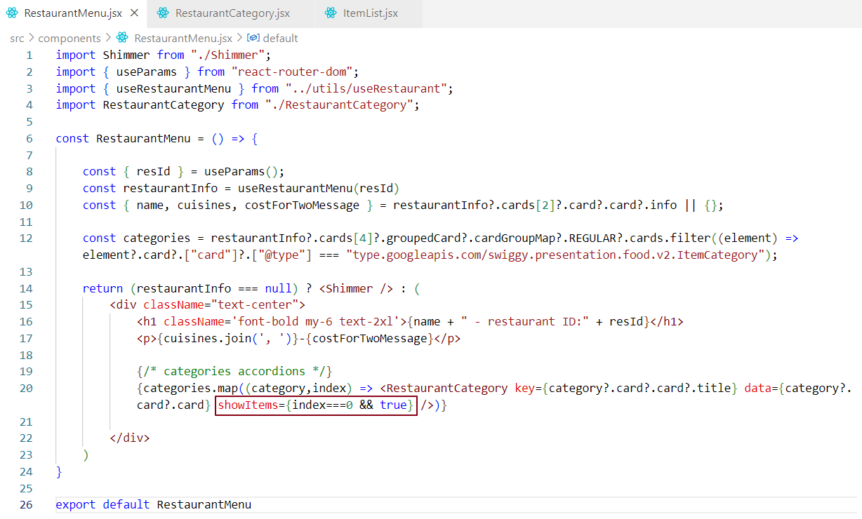

Child component -

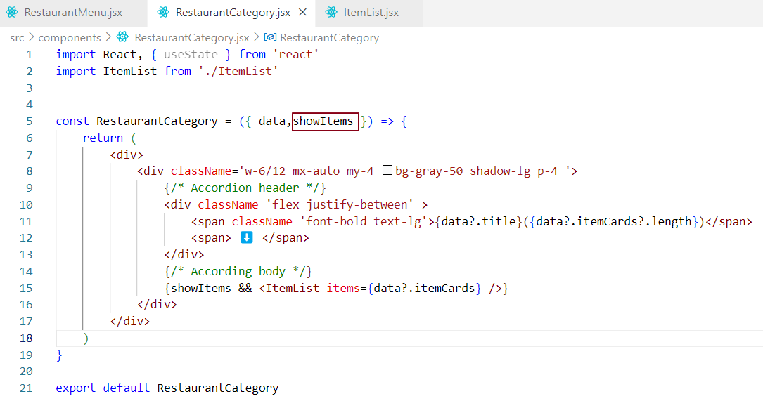

The parent component is controlling its child components. Currently, the parent component manages the expansion of the child components. In this case, the parent is controlling the expansion of the first child component.

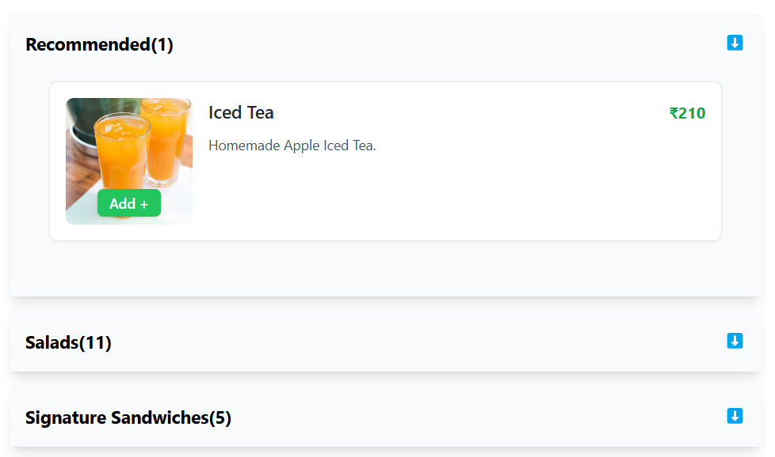

So far, we have hardcoded the index to display one accordion at a time. When one accordion is expanded, the others cannot be expanded simultaneously. To make this functionality dynamic, we need to store the index of the expanded accordion in a state variable, which we’ll call showIndex. If showIndex is 0, the first accordion will be open while all others are collapsed. Similarly, if showIndex is 1, the second accordion will be open, collapsing the rest, and so on.

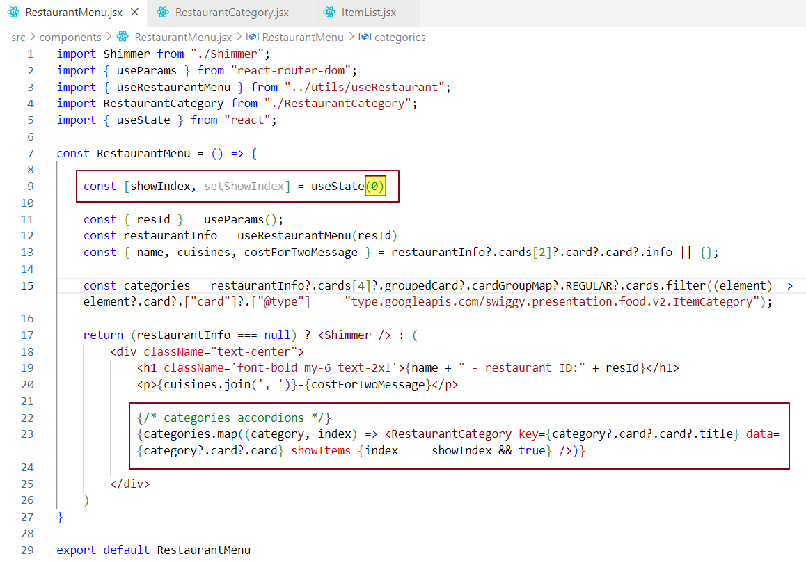

In the current setup, the showIndex state in the parent component, RestaurantMenu, determines which child category accordion is expanded. However, when a child accordion is clicked, we want to change the showIndex state to expand that specific child while collapsing the others. The challenge here is that the showIndex state is not stored in the child components; it is passed down as a prop from the parent. Since we cannot directly modify the parent's state from the child, we need to find a way to update the showIndex state in the parent when an accordion in the child component is clicked. This will allow us to dynamically control the expanded accordion from the child while ensuring the state remains in sync with the parent.

Let's start coding!

Parent Component -

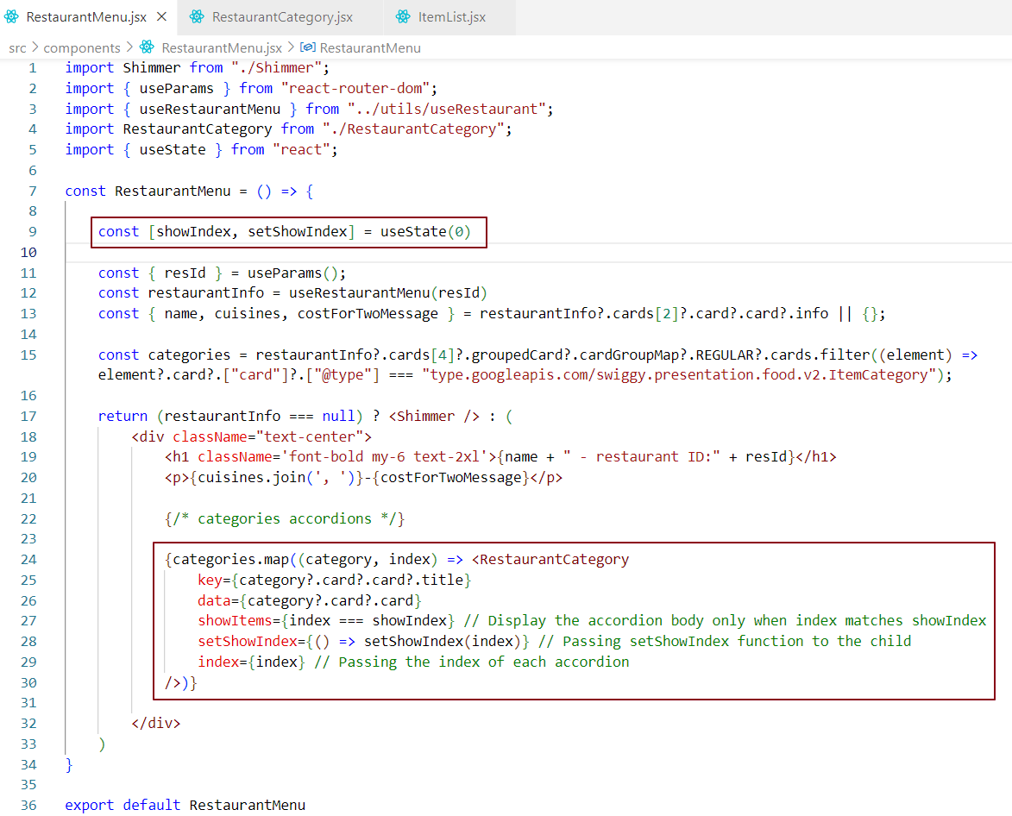

Child Component -

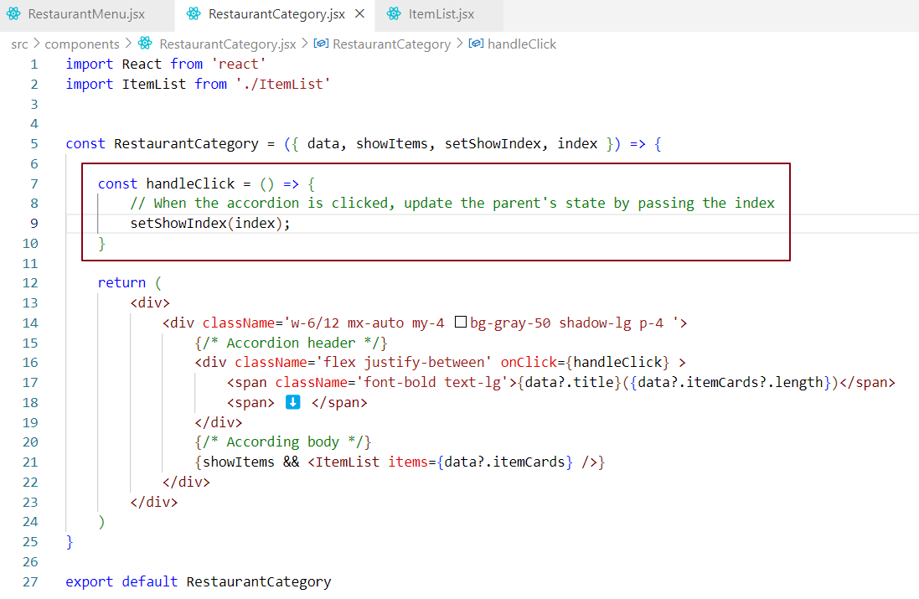

### Code Explanation -

**Parent Component (RestaurantMenu)**

* The showIndex state determines which accordion is expanded.
* The setShowIndex function is passed to the RestaurantCategory as a prop so that each child can update the parent’s state.
* The index is also passed to identify which accordion was clicked.

**Child Component (RestaurantCategory)**

* The handleClick function calls setShowIndex(index) to update the parent's state when the accordion is clicked.
* This ensures that when the user clicks on any accordion, the showIndex is updated to the corresponding index of that accordion, and the parent component will reflect the updated state.

### Why This Works?

* When a user clicks on a restaurant category accordion, handleClick in the child component triggers the update of showIndex in the parent component, which causes a re-render of the parent component.
* The parent component then re-renders the children with the updated showItems prop. This allows the correct accordion to be expanded, while all others are collapsed.

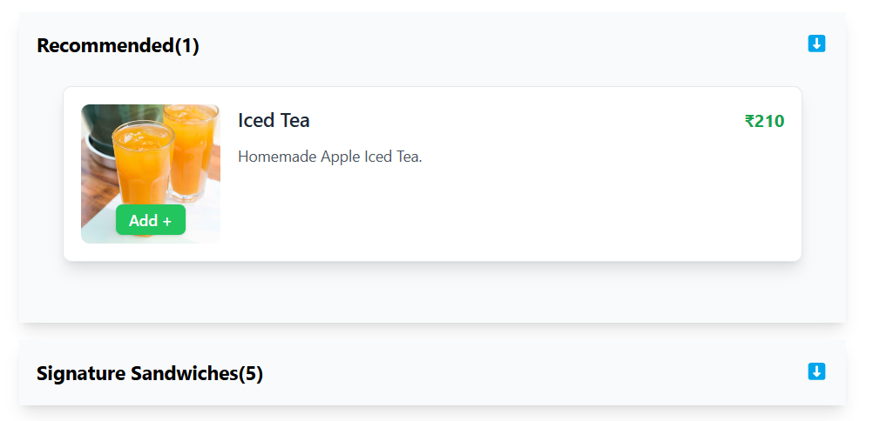

Now, when we expand the second accordion, it should collapse the currently expanded accordion and expand the clicked accordion. It is behaving as expected.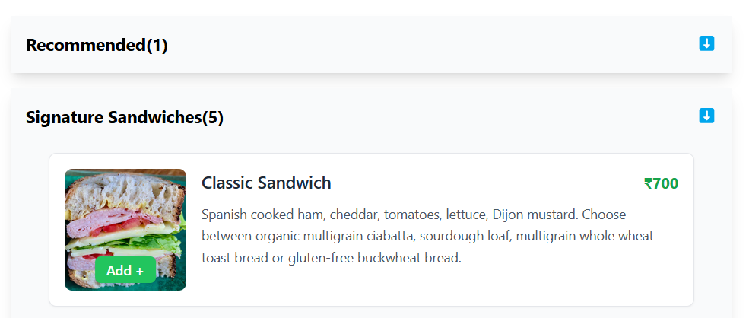

**On initial load, we are expanding accordion 1 while collapsing rest of the accordions.**

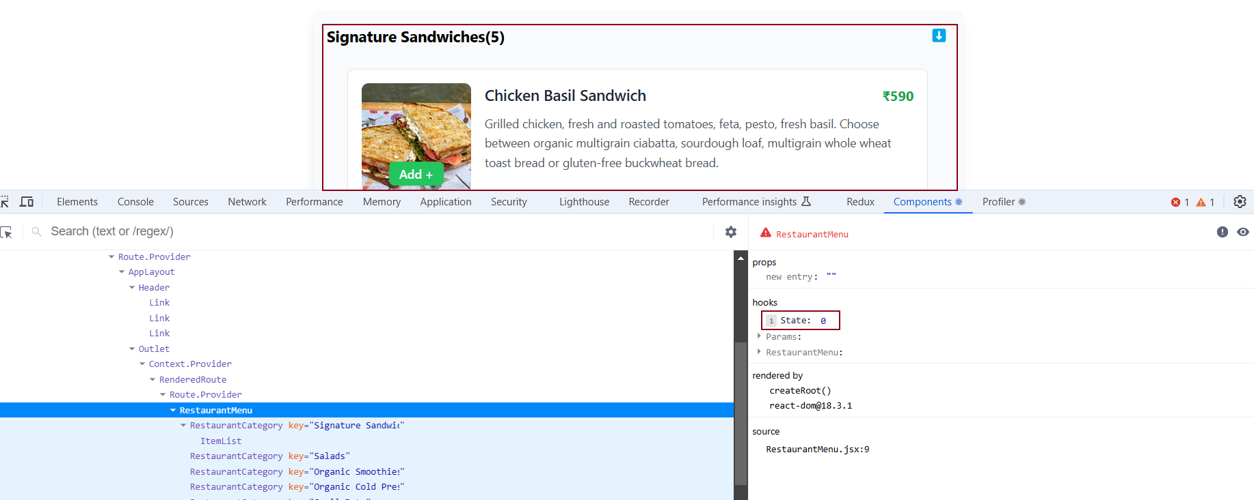

**Now let’s understand a concept props drilling.**

**Now if we click on second accordion -**

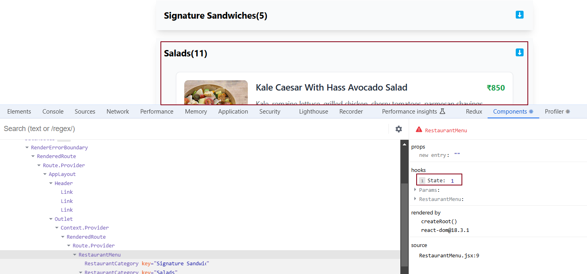

**Now if we click on Third accordion -**

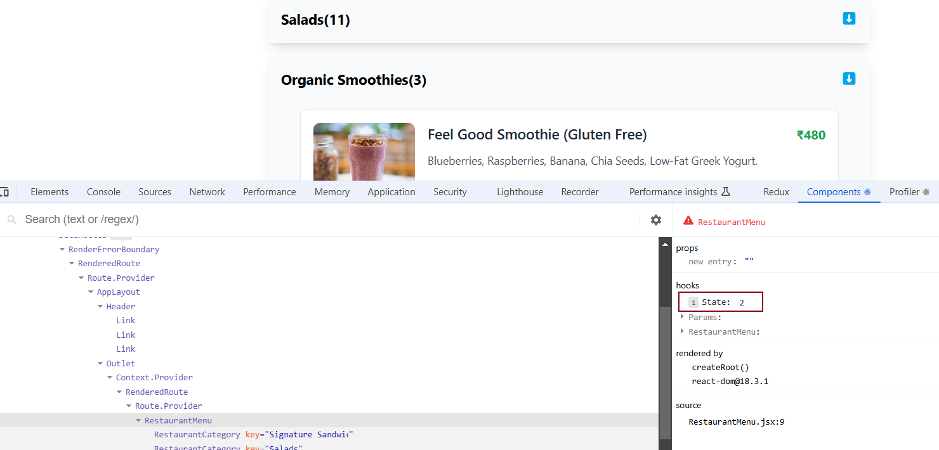

Each RestaurantCategory component (accordion) receives setShowIndex and showItems as props directly from the parent component, RestaurantMenu. These props are individually passed to each accordion by the parent. When we click on an accordion header in the child component, it triggers a state change in the parent, which we can clearly observe in the data layer. The highlighted state in the data layer represents the showIndex state in the parent component (RestaurantMenu), which is being controlled through the child component’s accordion header click.

What is 'Props Drilling' in React?

Props drilling happens when we pass data (props) from a parent component to its child, then to that child’s child, and so on, until the data reaches the component that needs it.

#### **Key Points:**

**Definition**:

Props drilling means passing props through multiple components in a chain to reach the target component.

**When it’s Okay**:

* It’s fine to use props drilling if the hierarchy is small, like 2–3 levels.
* It becomes difficult if the chain is too long because you’ll need to update many components just to pass the props.

**Problems with Props Drilling**:

* Props are passed through components that don’t even use them, which can make the code messy.
* If the props change, all components in the chain will re-render, even if they don’t use the props.

**React Best Practices**:

* Do not pass props to a component if it doesn’t need them.

In the example below, data is passed from the parent component RestaurantMenu to the target component ItemList through props drilling.

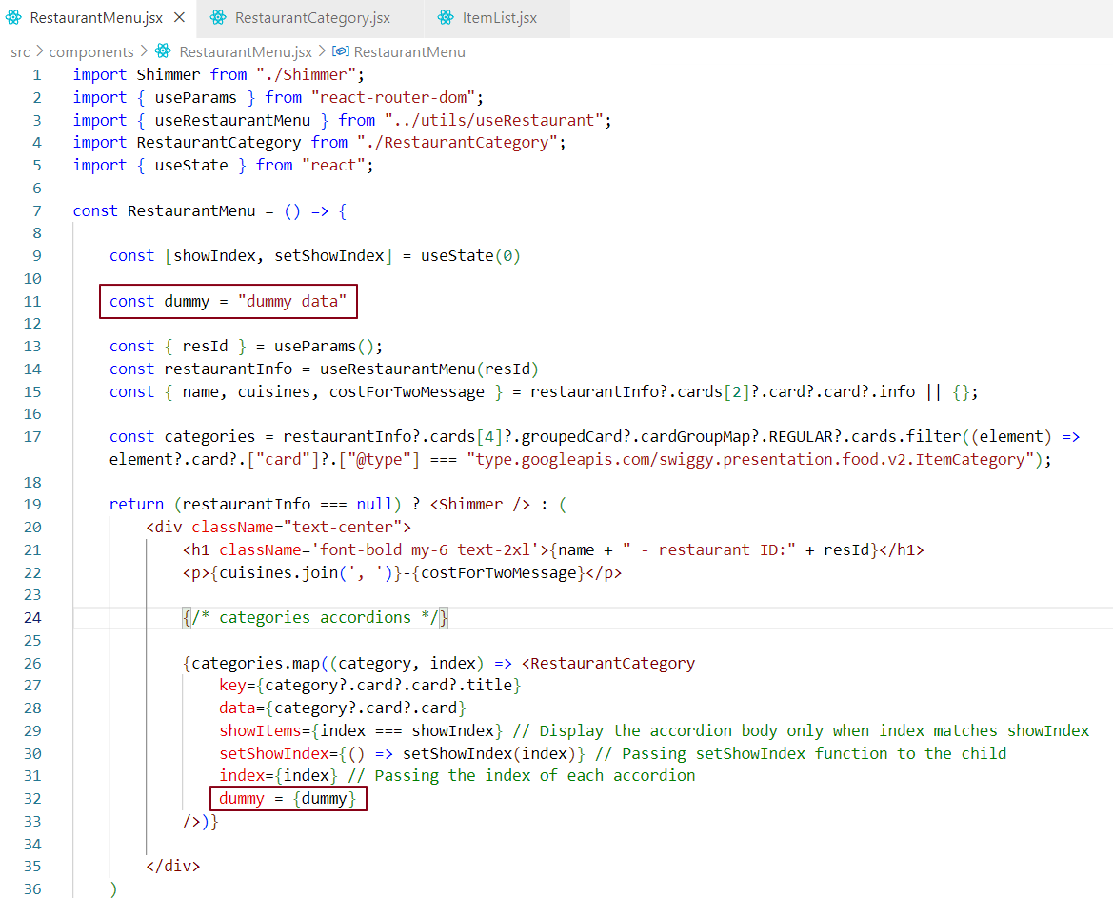

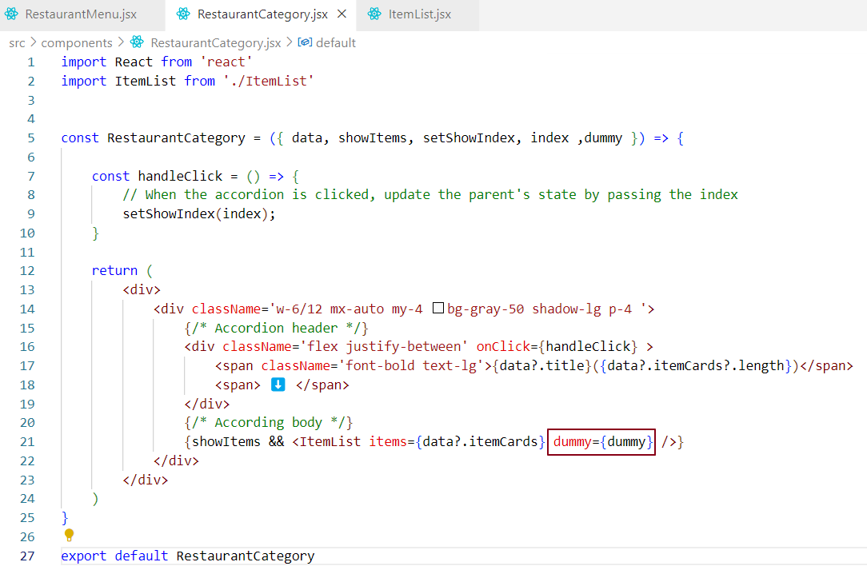

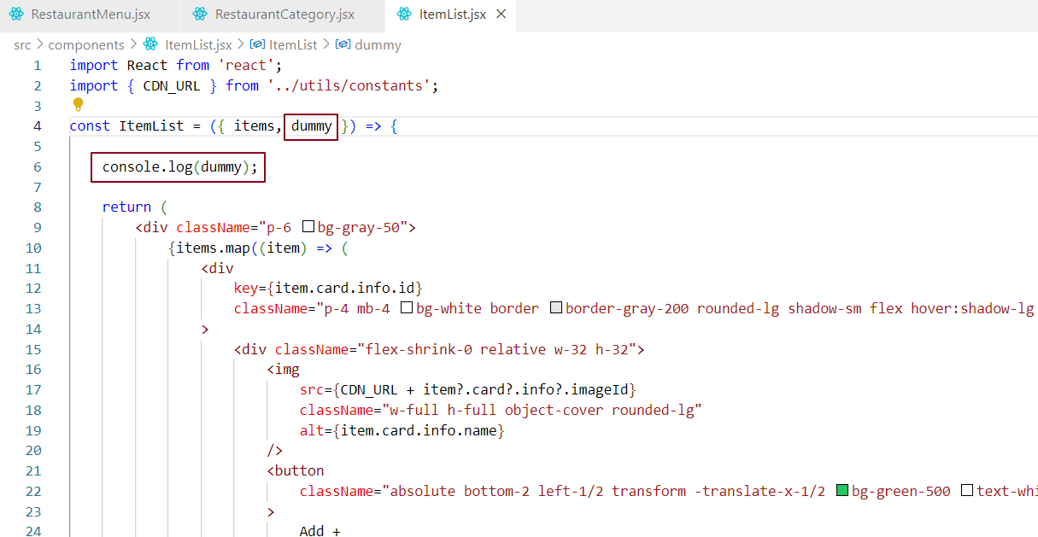

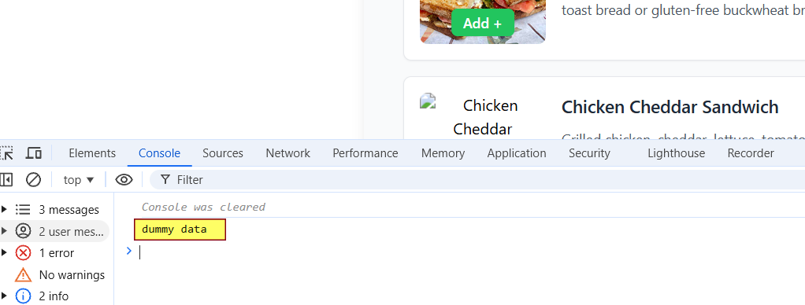

To overcome the issues associated with prop drilling, we use Redux and the Context API.

**Solution for Deep Chains**:

* For long hierarchies, use tools like **Redux** or **React Context API** to manage and share data without passing props through multiple levels.

In a large application, we often need to have global data that can be accessed anywhere within the app, regardless of the nesting level. To achieve this, react provides a powerful feature called React Context. By using React Context, we can avoid prop drilling.

What is React Context?

React Context is a feature that allows you to store data in a central place and make it accessible to all components in your React application, no matter how deeply nested they are. It is useful when you need data to be available across many components without the need to pass props manually through each level of the component tree.

**Advantages of React Context:**

1. **Centralized Data Access**: React Context provides a centralized location for storing data, making it easy for any component to access that data without needing to pass it through multiple layers of components.
2. **Avoids Prop Drilling**: Prop drilling refers to the process of passing data through many levels of components, even if some of them don’t need it. With React Context, you can skip this step and directly access the data from anywhere in the component tree, which simplifies your code and reduces complexity.
3. **State Management**: React Context can be used for managing global state, which can be shared across different parts of your application. It’s helpful when multiple components need to use the same data, such as user authentication status, theme preferences, or language settings.

**Important Note**:

* React Context should not be confused with local storage. Local storage is not reliable and updating it can be resource-intensive. React Context, on the other hand, is a more efficient way to manage global state in your application.

How can we create and use Context in a functional component?

To create and use Context in a functional component, you need to follow these steps:

1. **Create a Context:** Use React.createContext() to create a context. This will give you two things a **Provider** and a **Consumer**. The Provider is used to pass data down to components, and the Consumer is used to access that data.
2. **Wrap the component tree with the Context Provider:** Use the Context Provider to wrap your component tree and supply the value you want to share.
3. **Consume the Context in child components:** Use the useContext hook to consume the context value in any child component.

### Step 1: Create Context

### 

### Step 2: Use useContext to Access the Context in a Component

### 

### 

### 

### How can we Update Context in a functional component?

### Overriding the Default Value of Context -

If you have a default value for your context (e.g., a default user), but you want to dynamically update this data based on some logic, such as authentication, here's how you can do it:

**Scenario**:

* We are using context with a default value across multiple components.
* We want to override the default context value based on an API call, such as fetching user information during authentication.

**Solution**:

* Use React's useState to manage the context value dynamically in your root component.
* When the authentication logic runs (e.g. after an API call), update the useState variable to store the user data.
* Pass the updated value to the components using <ContextName.Provider value={contextValue}>.

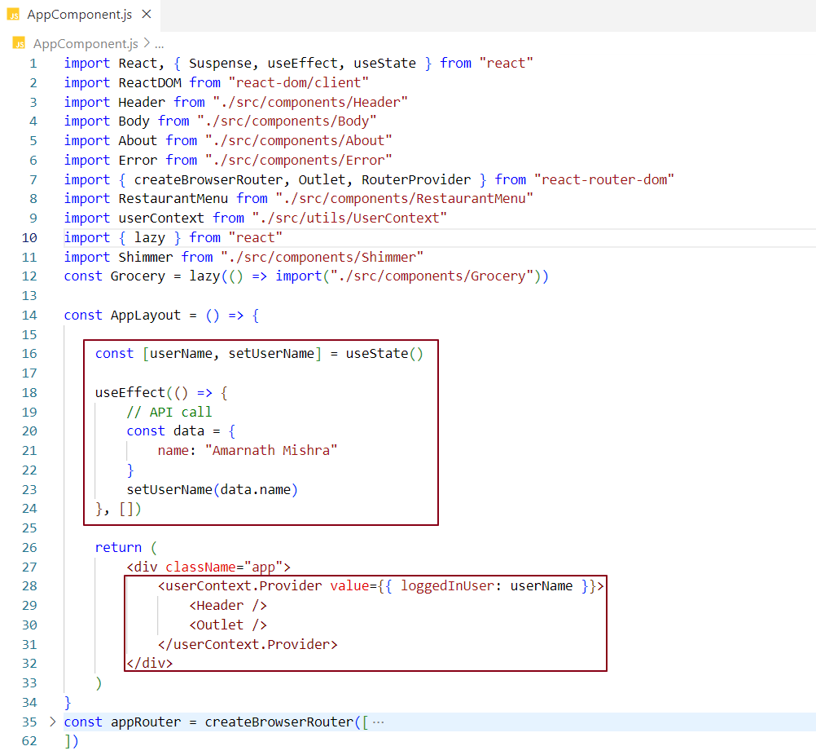

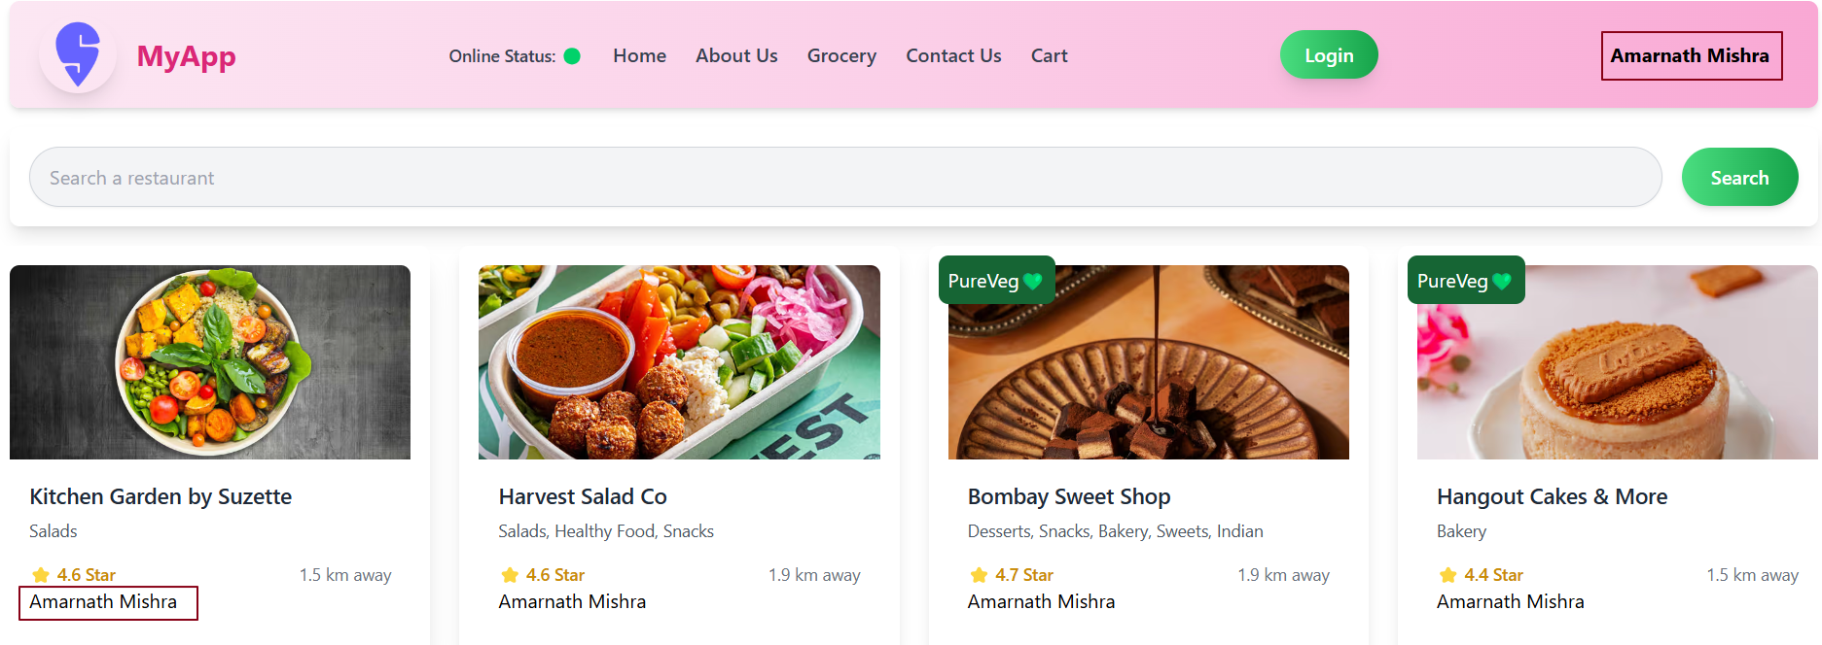

### **Providing Context to Specific Components**

* In our example, we have provided context data to the entire application.
* However, it's possible to make the context data available to **specific components** by wrapping those components with the <Context.Provider>.
* Components that are **not wrapped** by the Provider will only have access to the **default context data**.
* Components that are **wrapped** by the Provider will get the **custom context data** provided by the value prop.

**Why Provide Context to Specific Components?**

This approach is useful when

* Only a subset of components need access to the context.
* You want to limit unnecessary re-renders in components that don't need the context.

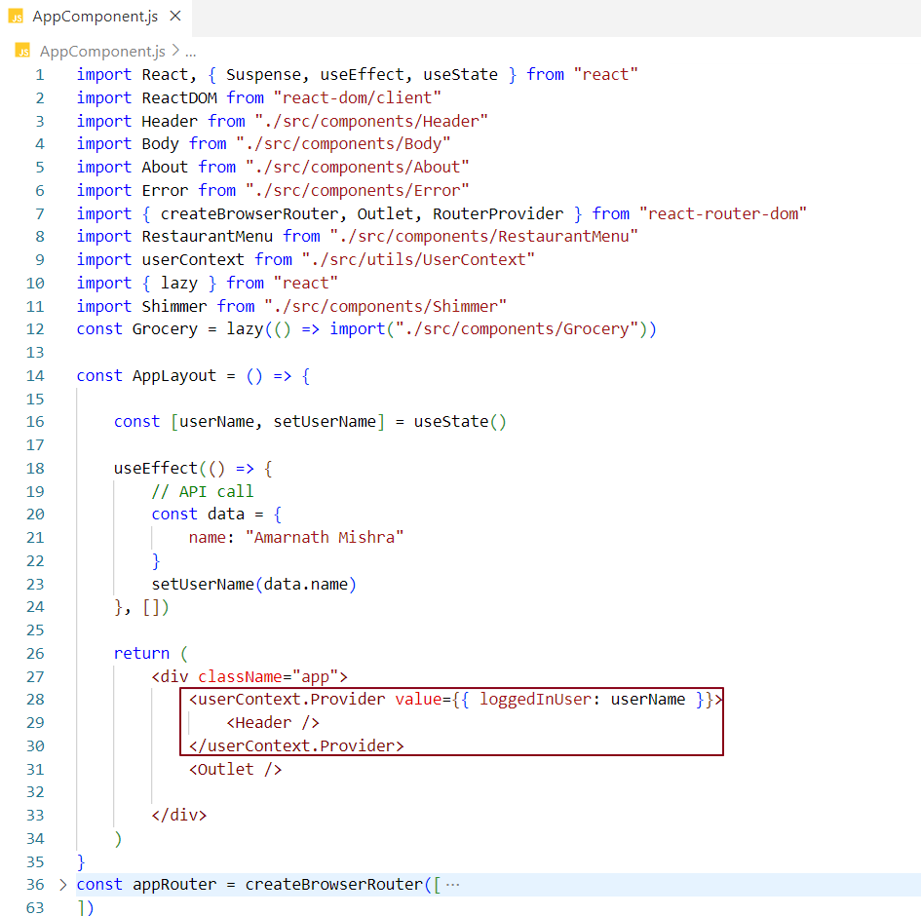

### **Explanation of Code Base: Providing Context to Specific Components**

**Context Creation** - A userContext is created using createContext () with a **default value** of "Default User". This is the fallback value if no custom context is provided to a component.

**AppLayout Component**

**State Management** - Inside the AppLayout component, useState is used to store the user's name (userName), which will be dynamically set based on an API call.

**API Simulation** - The useEffect hook simulates an API call to fetch the user’s name. Once the name is fetched, it's set in the userName state.

**Context Provider** - The context (userContext.Provider) is used to pass the value of userName as the loggedInUser property to the Header component. Only components wrapped by userContext.Provider will have access to this updated userName value.

**Header Component** - The Header component is wrapped with userContext.Provider, which means it gets the context data (loggedInUser with the dynamic value of userName).

**Body Component** - The Body component is **not** wrapped by userContext.Provider. Thus, it will only have access to the **default context value** ("Default User"), not the updated userName.

**Routing with React Router** - React Router is used to manage the routes of the app. The AppLayout component serves as the root layout, where the context is provided to certain components (Header in this case). The Outlet component is used to render child routes (like Body, About, RestaurantMenu, and Grocery).

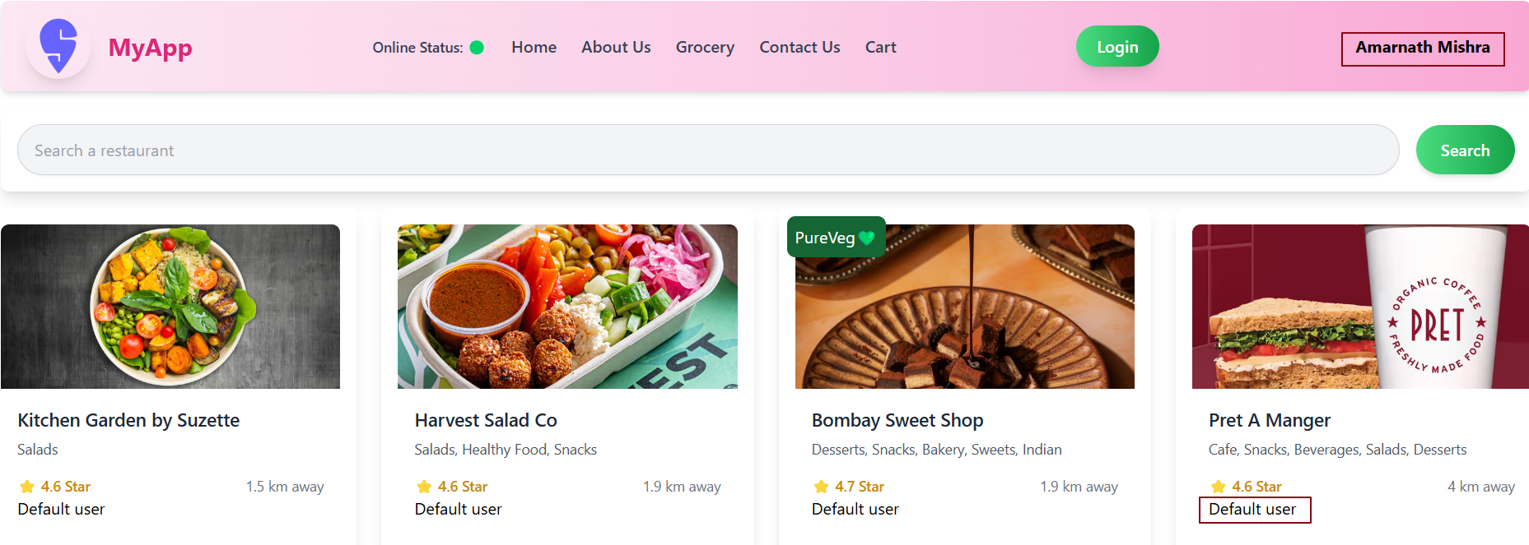

In our app, the Header component receives the overridden context data, while the Body component receives the default context data.

### **Nested Context Providers in React**

Yes, you can use **nested context providers** in React. This means you can have multiple <Provider> components where one is inside the other, each providing a different value to different parts of your app.

**Important Points -**

**Multiple Providers** - You can place more than one context provider, one inside the other.

**Value Override** - The inner provider can change the value of the outer provider. Components wrapped by the inner provider will use its value, while components outside will use the outer provider’s value.

**How It Works**:

* The **inner provider**’s value overrides the **outer provider**’s value for the components it wraps.
* Components outside the inner provider will still use the outer provider’s value.

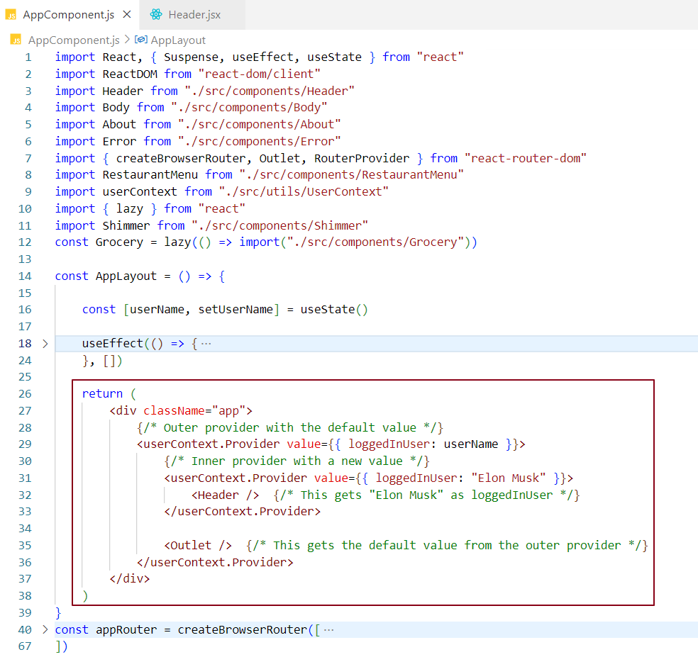

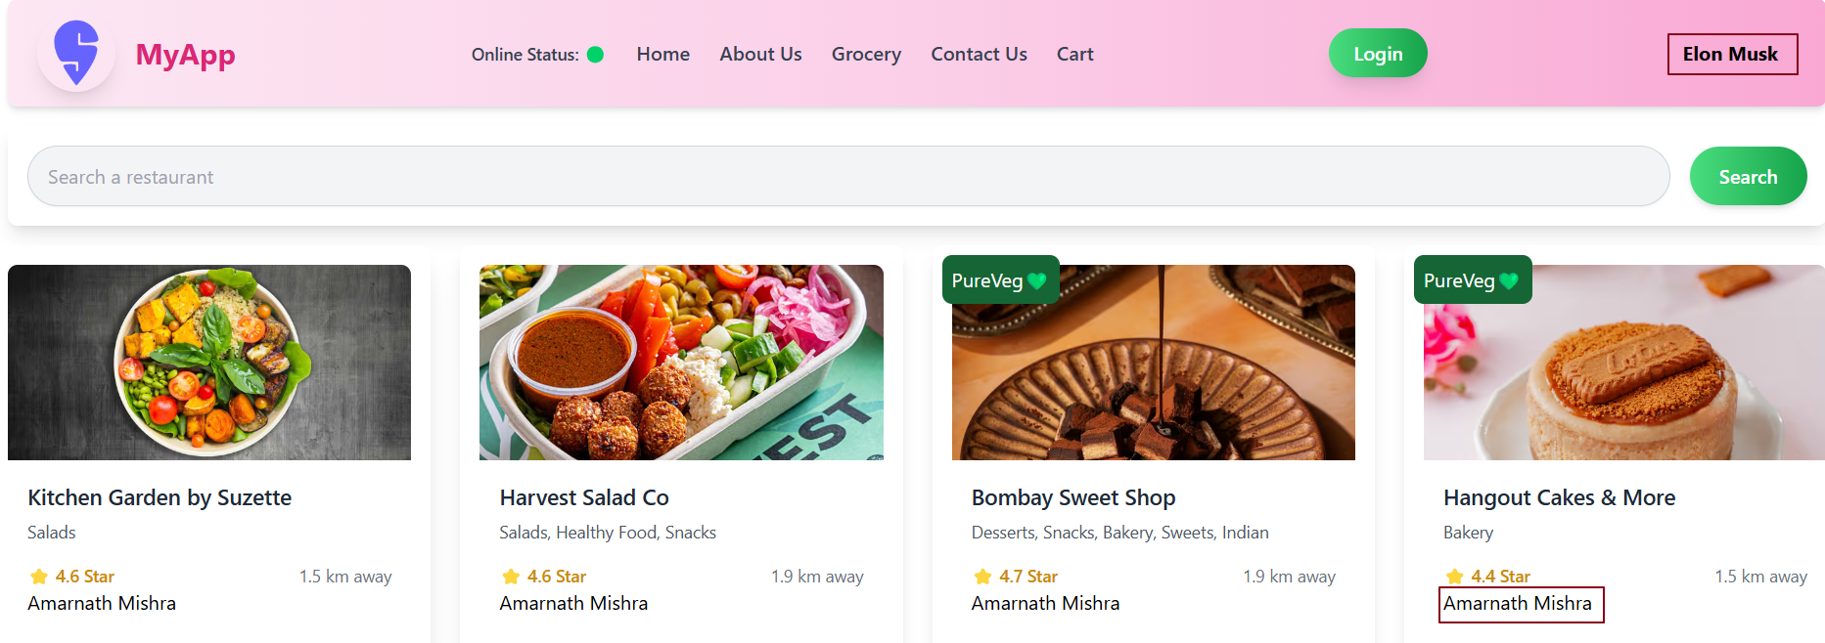

Changing Context data dynamically –

**Objective:**

We want to create a textbox in the **Body** component. When we type in the textbox, we want to update the context data, and this change should reflect across all components that are using the context.

### ****How to Achieve This?****

* The context data is initially set in the **App** component.
* To modify the context data from the **Body** component, we need access to the setter function that updates the context data.
* To pass this setter function from the **App** component to the **Body** component, we need to make sure that the setter is available via context. This allows the **Body** component to update the context data.

### ****Steps to Implement -****

1. In the **App** component, define a function that updates the context data.
2. Provide the function (setter) along with the context value to make it accessible in child components.
3. In the **Body** component, consume the context and use the setter function to update the data when the user types in the textbox.

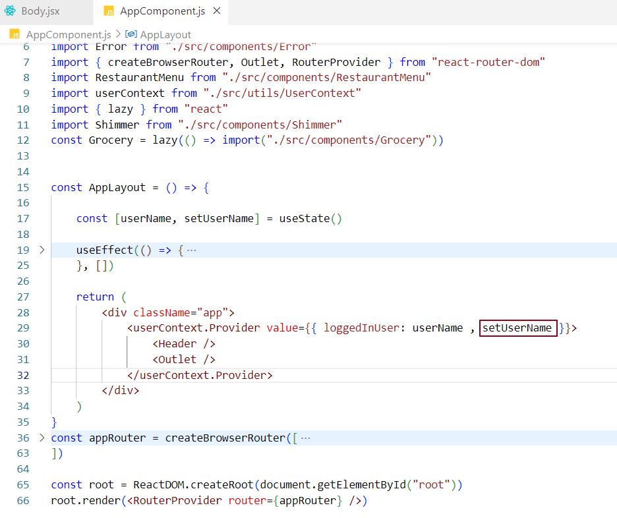

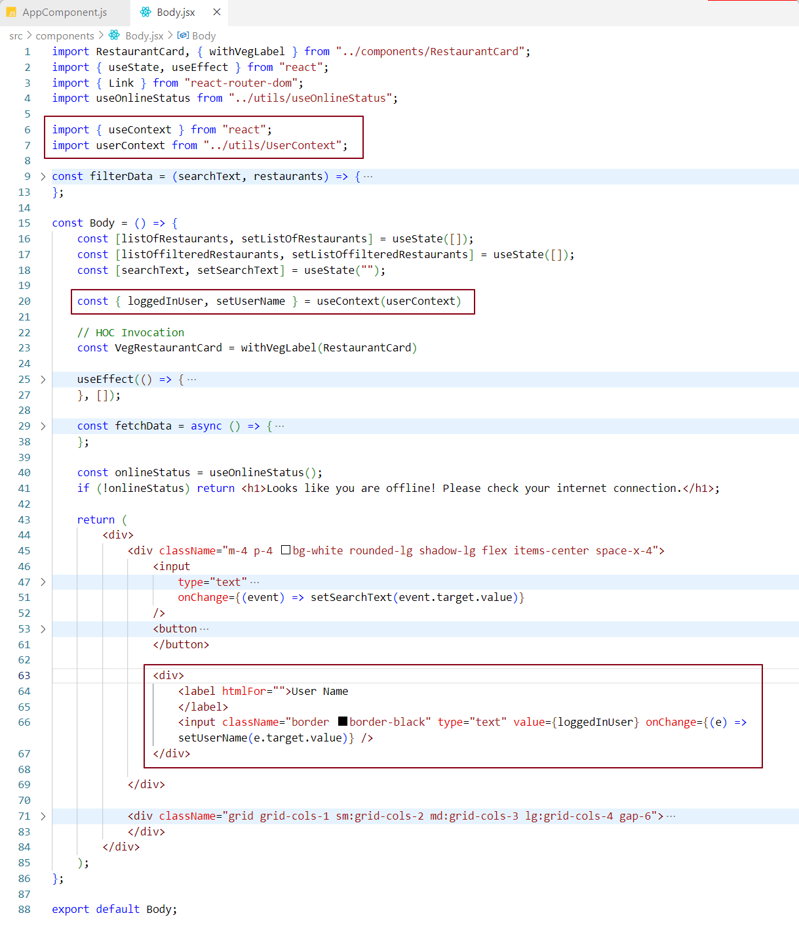

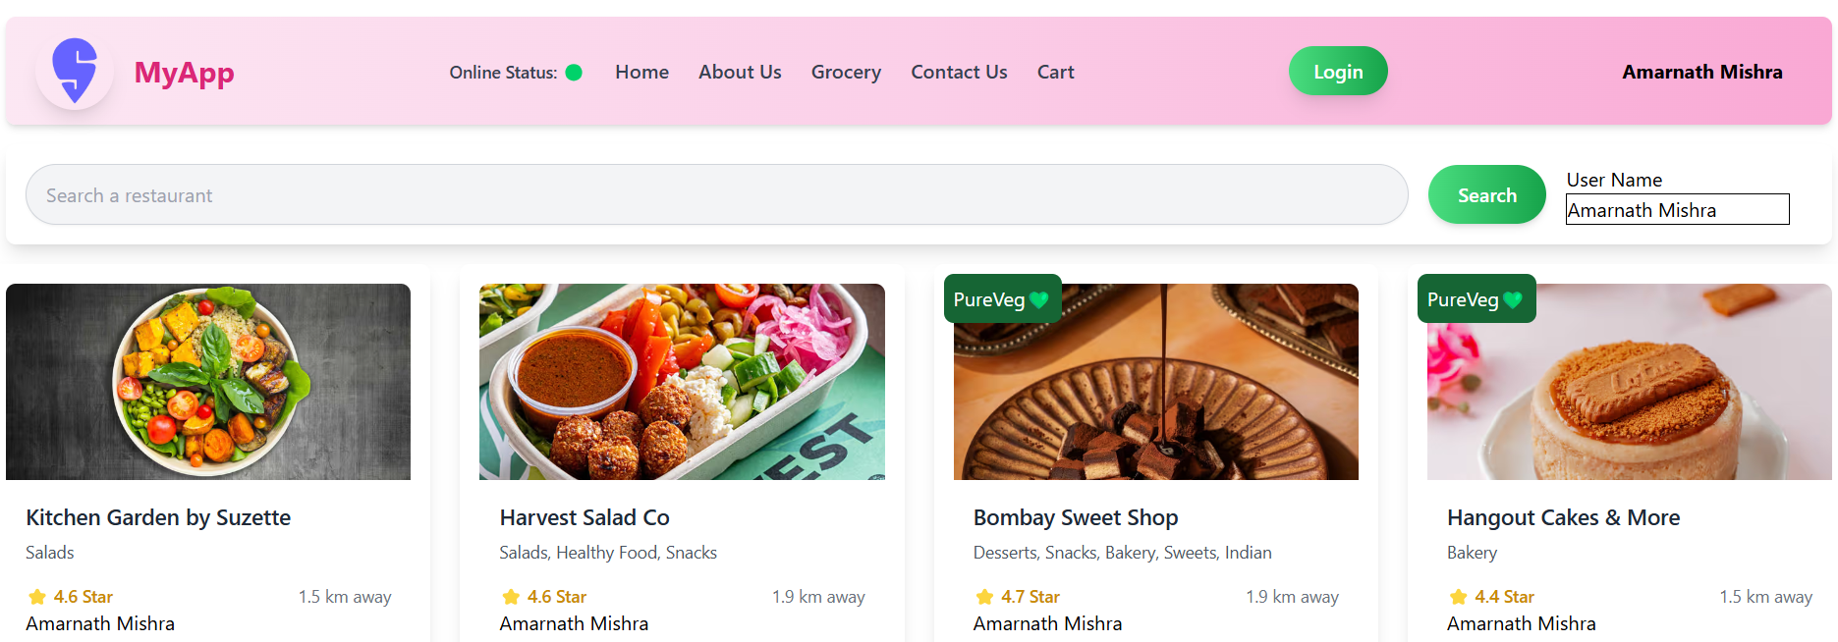

The moment I start typing in the Username textbox, you'll notice that wherever this context data is being used, it will be updated.

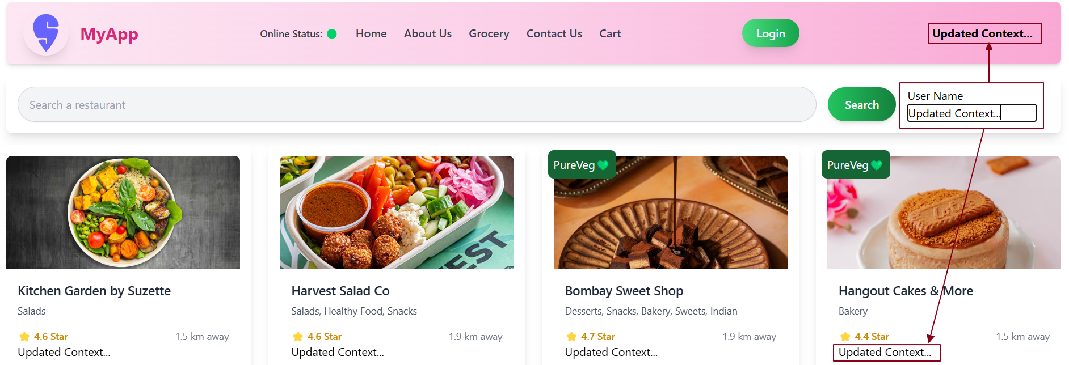

### **Effect of Context Changes on Lazily Loaded Component**

#### **Scenario Overview:**

* **Grocery** is a lazily loaded component in the app.
* Initially, when on the home page, the **Grocery** component's bundle code is not loaded.
* When you navigate to the **Grocery** page, the code for the **Grocery** component is fetched and loaded.
* While on the home page, we update the context value (such as a username in the textbox), and even though the **Grocery** component is not loaded yet, the context change will still affect it when it eventually loads.

#### **Key Points -**

**Lazy Loading -**

* The **Grocery** component is lazily loaded using React.lazy(). This means its code is only fetched when the user navigates to the **Grocery** page.
* Until that point, the code for the **Grocery** component is not part of the initial bundle, reducing the initial load time of the app.

**Context Changes -**

* The **userContext.Provider** wraps the entire app, providing context data (like the loggedInUser state) to all components, including **Grocery**.
* When the username is updated in the **AppLayout** (via a textbox), the context state is updated globally.

**How It Works -**

* When the textbox in the **AppLayout** changes the username, the context state is updated.
* Even though the **Grocery** component's code hasn't been loaded yet (because it’s lazily loaded), the context update happens immediately.
* When you click on the **Grocery** page, react loads the **Grocery** component code. By the time the component is rendered, the context data is already updated.
* Thus, when **Grocery** is rendered, it gets the updated context value, even if it wasn’t available at the time of the textbox change.

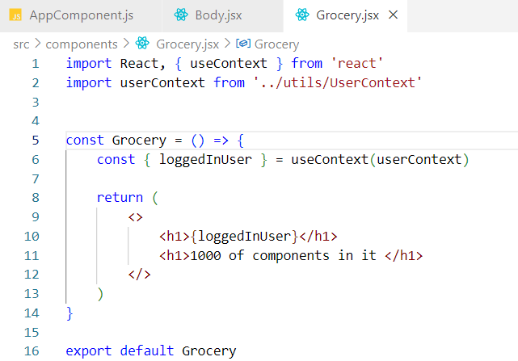

Any change in the context data from the Body component will also affect the lazily loaded component, such as the Grocery component.

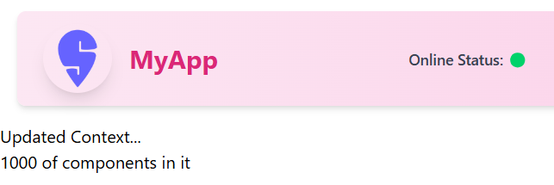

Difference Between State and Props?

* **State** - State is used to store information that belongs only to one component. It's like a variable inside the component that can change over time. For example, when you type in an input box, the text in the box is stored in the state.
* **Props** - Props are used to send data from one component to another. They are like parameters that the parent component gives to its child component. Props are read-only, meaning the child component can’t change them.

**How Do We Pass Data from Parent to Child Component?**

* To pass data from a parent component to a child component, we use **props**. The parent component sends the data to the child component using props.

How Do We Pass Data from Child to Parent Component?

To send data from a child component to a parent component, you need to use a special method, because props only work from parent to child. There are two ways to do this:

1. **Lifting State Up**: This means you move the state to the parent component and give the child a function to call, so the child can send data to the parent.
2. **Custom Hooks**: You can create a custom function that shares state and logic between the components.

**Notes –**

**MyContext.Provider**: The Provider component is used to pass down the value to all the components inside it.

**useContext (MyContext)**: The useContext hook allows you to access the context value inside any functional component.

2.30.15 >>>>>>> How to access context data in a classBased component <<<<<< 2.34.55 (5 mins)